**Pre-lab 3**

1. Rename repo and have a homework and lab folder

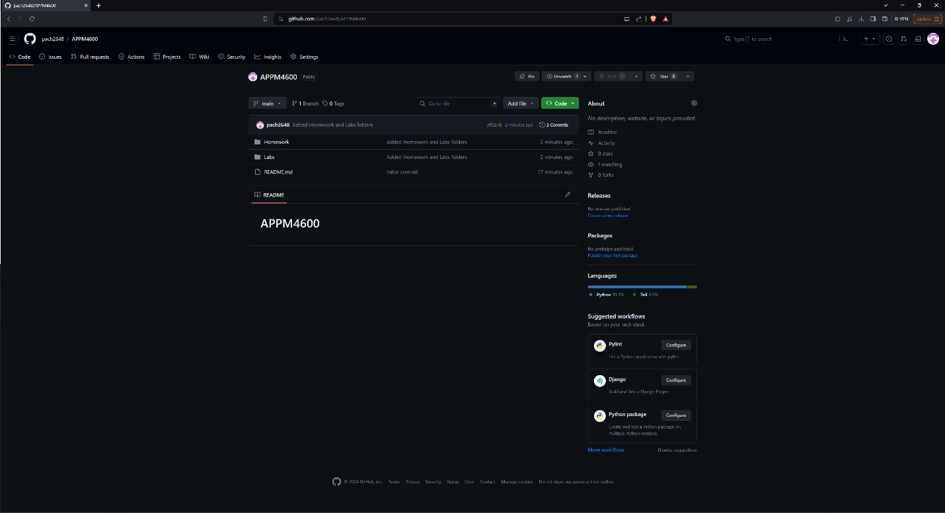

1. Subfolders for each labs and homework and example codes from lecture

